Student’s name | …………………………………………………….…… | Grade | 5
Subject | Computer | Week No. | 12
Lesson Title | Slide Master | Unit
Worksheet No. ( 12 ) (Answer)

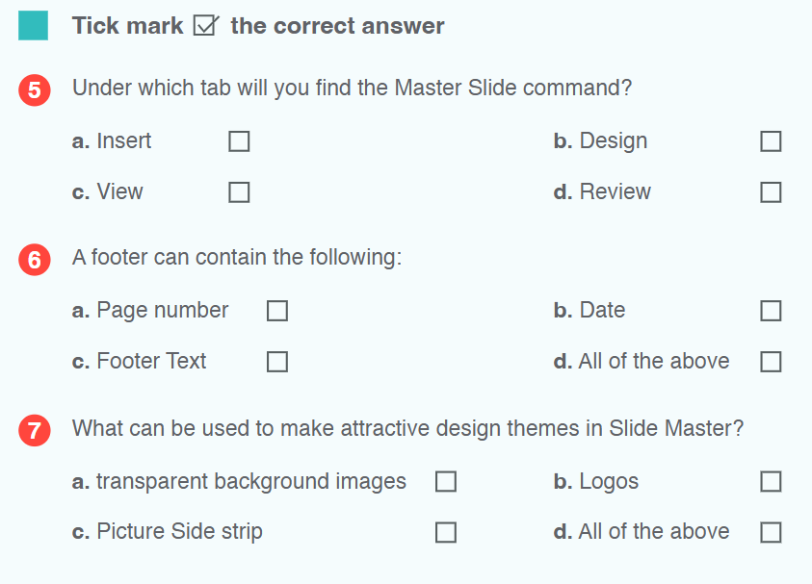
Question A:

✔️
✔️
✔️
Good Luck

